**Table of Content**

1. **Technology**
   1. **Introduction of BCI Technology…………………………………2**
   2. **Assess the current and future of BCI……………………………3**
   3. **Market Potential…………………………………………….….4,5**
2. **Importance to Australia & Role of Government**
   1. **Actual and potential Impact of the BCI to Australia……….….6**
   2. **Role of Government……………………………………………...7**
3. **General Purpose Technology………………………………………...8**
4. **Diffusion of innovation……………………………………………….9**
   1. **Rate of adoption**
   2. **Stage of BCI in the technology Adoption life cycle**
5. **Dominant Design**
   1. **Product Category……………………….…………………………10**
   2. **Dominant Design in Product Category…………………………..11**
   3. **Technology Cycle of Product Category………………………….11**
6. **Reference……………………………………………………………...12**

**Brain computer interface**

**1.1 Introduction of BCI Technology**

There are a lot of people in this world who have been suffering from disabilities such as paralysis, not able to see properly, walking issues, etc. So, to eliminate their issues, since 1924 scientist have been working on a technology, which is known as “**Brain-computer interface** A Brain Computer Interface (BCI) is a collaboration in which a brain accepts and controls a mechanical device as a natural part of its representation of the body.”

Types of BCI

1. **Invasive**

In this system, hardware needs to be in contact with the brain to capture the data.

1. **Non-invasive**

In this it is not necessary to be in contact with the brain, However, hardware needs to apply on the scalp and from there it will fetch the signals

BCI technology has been implementing all the industry sector such as HealthCare, defence, Automotive, gaming & entertainment etc.

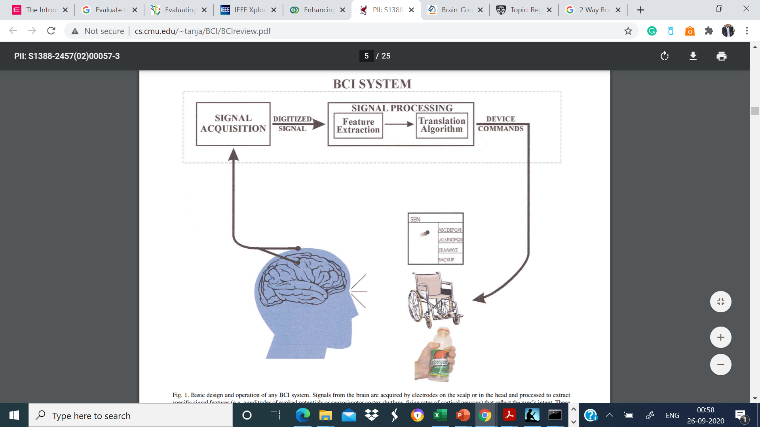Source: <http://www.cs.cmu.edu/~tanja/BCI/BCIreview.pdf>

**Fig-1**

**1.2** **Assess the current and future of BCI**

The technology assessment is very crucial because it is the only way to know the potential and its impact on society. Assessment will determine the consequences of the technology and therefore, scientists will do the improvisation according to the environment & audience needs.

According to the author Gabriel T. Velloso paper, assessment means an evaluation of current applications and identify the more problems and foster the future application based on the technology accordingly.

According to Gabriel, there are two types of assessment happens

1. **CTA (constructive Technology assessment)**, is the kind of assessment that occurs at the initial stage of application development to monitor and control the direction of technology’s development.
2. **FTA (Future-oriented Technology Analysis)**, it is used to assess the emerging technologies, its development pathways, and their future potential impacts on audiences. This helps to a better understanding of the future potential and the areas where the technology will fulfil the requirement of the mainstream market.

Nowadays, BCI research has been increasing exponentially because it is the demand of the present situation. Therefore, Scientist has been trying to integrate this technology with various sectors such as Healthcare, smart Environment, Neuromarketing and advertisement, Defence, Education and self-regulation, games and entertainment & security and authentication.

Therefore, CTA will assess above mentioned sectors and their potential impacts.

* **According to the WHO disability data**, 15% of population have been suffering from disability & out of those 3-4% are experiencing serious disability issues. Therefore, scientists aimed to resolve these problems by using the BCI technology & EEG and their aim is to prevent the motion sickness issues, detection and the diagnosis of tumours, Brain disorder and rehabilitation and restoration of disabilities, physical disorder such as paralysis & handicaps.
* BCI also help the disabled people by creating a smart environment such as smart house. Scientist have integrated the BCI with IOT. They have created a brain computer interface based smart living environmental auto adjustment control system which mainly monitor the mental state and act accordingly**.**

 **Source: Sarah N. abdulkader .Ayman Atia. MostF-Sami M. Mostafa. Brain Computer Interfacing:Applications and challenges.Egyptian Informatics Juournal(2015)16,213-230**

**Fig-2**

However, FTA will assess the future of BCI technology that’s the reason why Scientist have been working on BCI technology in order to enhance its functionality and also wanted to integrate it with other technology in order to cover non-medical and medical aspects of Human life’s. According to the Jerry J, Shih journal, the future of BCI mainly depends on three critical areas

1. Development of comfortable, convenient and stable acquisition of signal hardware
2. BCI validation and dissemination
3. Proven BCI reliability and value for different user population

In future, Scientists also want to minimise the system’s response time, security issues, restore the neural features, privacy issues & error, Neurorehabilitation, better neurofeedback, mind to mind control etc.

In addition, this technology aims to improve the and change the human life mainly for the people with serious disabilities. Therefore, scientists have been working on its challenges and enhancement.

**1.3 Market Potential**

While working on such technology, it is very important to know the **market potential** and the mainstream market in order to get the clear picture of future of the BCI technology. otherwise, the value of BCI technology will not reflect its accurate and true value to the audience. In simple term, market potential is the total demand of a product in business environment So, whenever it comes to market potential, we mainly consider five things

1. Market Size
2. Market growth
3. Competition
4. Profitability
5. Consumer and product type

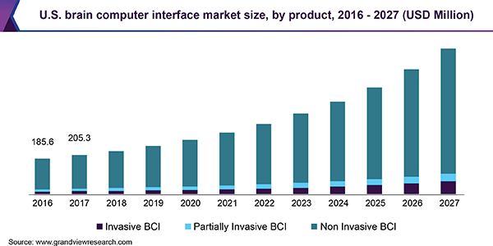

Source: <https://www.grandviewresearch.com/industry-analysis/brain-computer-interfaces-market>

**Fig-3**

According to the valuates report, the global BCI market size was estimated at USD 1.36 billion in 2019 and is expected to reach USD 3.85 billion by 2027. According to the WHO, by 2030, about 82 million will be affected by the dementia and it will reach 150 billion by 2050. It also enhanced the gaming and smart phones quality by integrating it with virtual reality. there are many more examples available for the market potentials. Therefore, it shows that the potential demands of BCI in future.

**2. Importance to Australia & Role of Government**

**2.1 Actual and potential Impact of the selected technology to Australia**

According to the Australian network on disability statistics & National survey of mental health wellbeing, a disability is any condition that restricts a person’s mental, physical movements. Over 4.4 million of people in Australia have some forms of disability.

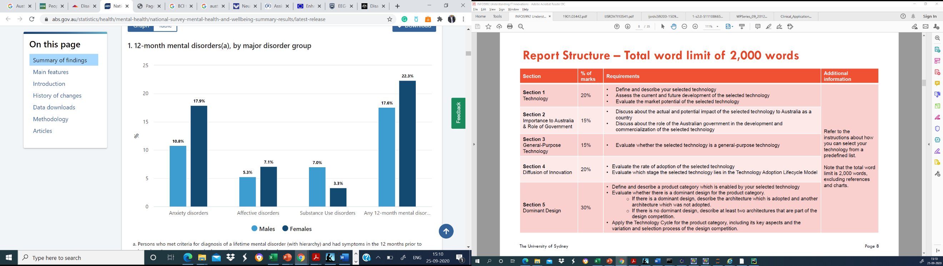

Source: <https://www.abs.gov.au/statistics/health/mental-health/national-survey-mental-health-and-wellbeing-summary-results/latest-release>

**Fig-4**

Due to the above-mentioned issues, The Health department of Australian government has decided to invest $924,100 for research on cutting edge technologies in order to help the disabled audience and Brain computer interface has been selected as a very promising technology which really can impact the human’s life. So, the government has appointed Professor Arthur Lowery, Professor of Monash University to commercialise the brain computer interface projects. Their main focus is on Healthcare. For instance, Invasive BCI helps in order to regain the damaged vision, assist the paralytic patients, cochlear implants, chips implantation etc.

Government has named this initiative as” New Frontiers for vision” and they allowed the researchers to work harder in order to help disabled people and for their better future.

**2.2 Role of Australian Government in development and commercialisation**

As mentioned, Australian government has taken great initiative to help people. They have been investing very huge amount of money in R&D sector. However, apart from investment they also have to support BCI & other technologies in other ways too. According to the National Innovation and science agenda report,

* government should ensure that their foreign trade & national polices should be in the favour of the betterment of people
* they should encourage, emphasis and collaborate private and public research sector of BCI technology.
* They should change visa system and invite more overseas research leaders and entrepreneurs for better leaderships & better vision for the country.
* They should allow more start-ups & private firms to work on BCI technology and improve their reforms, ease the restrictions and share their ownership
* They must keep themselves updated with market potential and time to time they must assess the BCI technology to know its potential impact on the society.

**3. General Purpose Technology**

**Yes, BCI is a general-purpose technology**. In order to become GPT the technology should possess four attributes which I have proven in the chart.



**Fig-5**

There is evidence for low end market disruptions such as Facebook is trying to create Hand free computing software, Uber cognitive Services etc

**4. Diffusion of Innovation**

**4.1 Rate of adoption**

Now, it is very essential to understand the rate of adoption of BCI technology because it will help the researcher to know about the market potential and impact of technology on the audience. However, in some sector it has been adopted while in others trail & research has been conducting in order to reduce the associated risks and then launch it into the market. So, rate of adoption depends on five attributes which I will presented below:



**Fig-6**

**4.2 Stage of BCI in the technology Adoption life cycle**

When it comes to the technology adoption cycle, BCI is a very mature technology & it comes in the Early majority in almost every sector such as Healthcare, defence, smart house, etc. It is all around humans especially in health care, I would say it has crossed the chasm, and now even late majority and laggard have been using BCI because the technology & its applications have been mitigating the problems of disabled peoples, assisting doctors to better detection of disease. To understand the adoption, we have to understand that the right environment is important where various people will adopt the innovation.

**Therefore, in general I would it has crossed the chasm because it has been eliminating human problems and making their life better.**

**5. Dominant Design**

**5.1 Product Category**

Basically, product category means all the products offering same features. as I have mentioned earlier about BCI Technology mainly acquits the brain signals using EEG. In the market there have been various types of EEG available such as Routine EEG, ambulatory EEG, video telemetry, etc. So, I have considered commercial EEG headset as a product category which is used to record the brain activity. According to the manufacturer, EEG headsets helps people in order to reduce anxiety, makes meditation easy, improve mental health, provides better concentration and it also helps in sleeping by measuring their brain activity. However, Researcher believes that it is not as much as powerful of EEG system for medical mainly because of two reason

1. Medical EEG system, places large number of electrodes over the scalp as compared to the EEG headsets.
2. As it’s main aim is to reduce anxiety, enhance focus and concentration. So, for that it takes less training data and it is not that much complex.

Due to the less complexity and structure it will not be able to fully capture the brain signal than Medical EEG system. Nevertheless, these devices have been improving their efficiency day by day and getting better when it comes to manage mental tranquillity. It will convert the brain signals into gibberish data and finally it will present the data in the score form in order to evaluate the level of anxiety, stress etc. EEG headsets will reduce the medicine intakes for such kind of issues.

**5.2 dominant design in product category**

No, there is not a dominant design about EEG Headset product category. However, there is design competition exist in the market. lot of companies have been working on the Commercial EEG Headset such as Muse2, Versus, NeuroSky MindWave Mobile 2, Emotiv Epoc+, Open BCI, etc.



**Fig-7**

Definitely there is a design competition and companies are trying to improve their quality and efficiency in order to attract the audience. However, there is no dominant design.

**5.3 Technology Cycle of Product Category**

Therefore, when we talk about Technology cycle, I think commercial EEG headset is currently in Era of fermentation because companies are striving to achieve the vertical and horizontal innovation in order to become dominant design and due to this there is very high market & design competition and according to the chart I guess few of the competitors are going to withdraw from the competition because they won’t be able to survive in the competition. So once Commercial EEG Heads gets its Dominant design then they will move towards era of incremental changes. The selection process of the design is completely depending on the consumer. Consumers are opting the manufacture as per their need such as if people want the headset which should be affordable, less complex and most importantly whether the product is fulfilling their purpose, then go for muse and when the consumer determined to get more accurate result, raw data and analytics along with aid to purpose then they can option for Emotiv Epoc+ etc.

**6. References**

1. [**https://www.who.int/disabilities/world_report/2011/report/en/**](https://www.who.int/disabilities/world_report/2011/report/en/)
2. [**https://www.ncbi.nlm.nih.gov/pmc/articles/**](https://www.ncbi.nlm.nih.gov/pmc/articles/)
3. [**https://www.researchgate.net/publication/236132285_Bridging_present_and_future_of_brain-computer_interfaces_an_assessment_of_impacts**](https://www.researchgate.net/publication/236132285_Bridging_present_and_future_of_brain-computer_interfaces_an_assessment_of_impacts)
4. [**https://www.prnewswire.com/news-releases/brain-computer-interface-bci-market-size-is-expected-to-reach-usd-3-85-billion-by-2027---valuates-reports-301058477.html**](https://www.prnewswire.com/news-releases/brain-computer-interface-bci-market-size-is-expected-to-reach-usd-3-85-billion-by-2027---valuates-reports-301058477.html)
5. [**https://www.health.gov.au/ministers/the-hon-greg-hunt-mp/media/new-frontiers-for-vision**](https://www.health.gov.au/ministers/the-hon-greg-hunt-mp/media/new-frontiers-for-vision)
6. **Sarah N. abdulkader .Ayman Atia. MostF-Sami M. Mostafa. Brain Computer Interfacing:Applications and challenges.Egyptian Informatics Juournal(2015)16,213-230**
7. [**https://www.industry.gov.au/data-and-publications/national-innovation-and-science-agenda-report**](https://www.industry.gov.au/data-and-publications/national-innovation-and-science-agenda-report)
8. [**https://core.ac.uk/download/pdf/32226056.pdf**](https://core.ac.uk/download/pdf/32226056.pdf) **(Role of Government)**
9. [**https://www.adlittle.com/sites/default/files/prism/1993_q1_23-27.pdf**](https://www.adlittle.com/sites/default/files/prism/1993_q1_23-27.pdf)
10. [**https://medium.com/better-humans/can-eeg-headsets-supercharge-your-brain-5bb788ed03fe**](https://medium.com/better-humans/can-eeg-headsets-supercharge-your-brain-5bb788ed03fe)
11. [**https://www.researchgate.net/publication/224085382_Clinical_Applications_of_Brain-Computer_Interfaces_Current_State_and_Future_Prospects**](https://www.researchgate.net/publication/224085382_Clinical_Applications_of_Brain-Computer_Interfaces_Current_State_and_Future_Prospects)
12. **Lecture slides**
13. [**https://www.ncbi.nlm.nih.gov/pmc/articles/PMC4383183/**](https://www.ncbi.nlm.nih.gov/pmc/articles/PMC4383183/)
14. [**https://www.ncbi.nlm.nih.gov/pmc/articles/PMC2862632/**](https://www.ncbi.nlm.nih.gov/pmc/articles/PMC2862632/)
15. [**http://www.123seminarsonly.com/Seminar-Reports/006/15117879-Brain-Computer-Interface.pdf**](http://www.123seminarsonly.com/Seminar-Reports/006/15117879-Brain-Computer-Interface.pdf)